**YOUR JOB**

**read + think + code**

**Cheating and copied assignments, programs, projects, or code segments, will not be tolerated and will get ZERO…!!.**

**Problem -1 (Change Order)**

**Tutorials**

**Write a java function that given a list of integers A, moves all even elements in a list of integers to the front of the list and all odd elements to the rear.**

**Hint: you do not have to maintain any order other than all evens appearing before all odds in the list For example: if the list is of the form [1,4,5,6,2,10] then the algorithm should create a new list of the form [4,6,2,10,5,1] and prints the elements of the resulting list.**

**public static void main(String[] args) {**

**int n;**

**int [] Input;**

**int [] Output;**

**char Temp=' ';**

**int counter=0;**

**Scanner sc = new Scanner (System.*in*);**

**System.*out*.println("Please enter array size");**

**n= sc.nextInt();**

**Input=new int[n];**

**Output=new int[n];**

**int o=n-1;**

**int e=0;**

**for (int i = 0; i < n; i++) {**

**Input[i]=sc.nextInt();**

**}**

**for (int i = 0; i < n; i++) {**

**if (Input[i]%2==0) {**

**Output[e]=Input[i];**

**e++;**

**}**

**else**

**{**

**Output[o]=Input[i];**

**o--;**

**}**

**}**

**for (int i = 0; i < n; i++) {**

**System.*out*.println(Output[i]);**

**}**

**}**

**Problem -2**

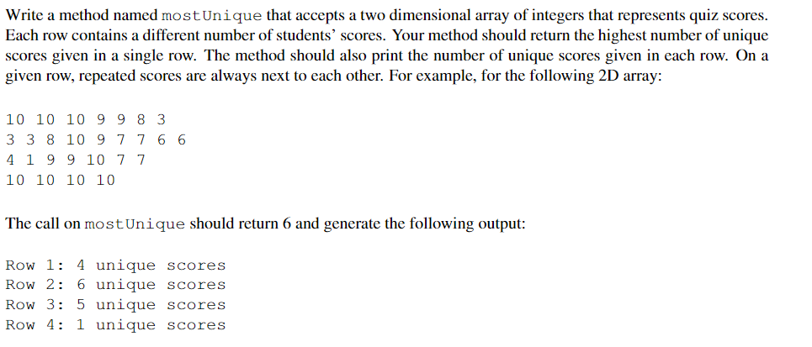

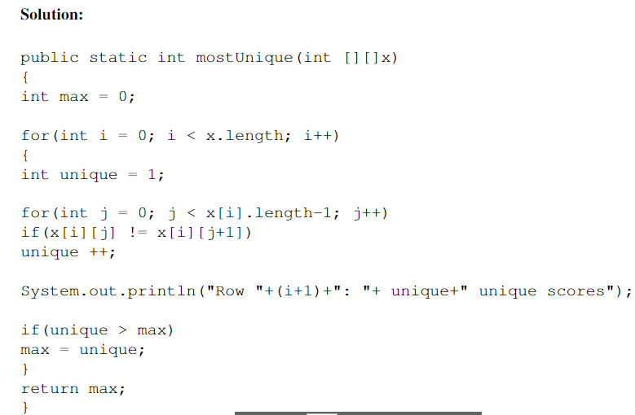

**Problem -3**

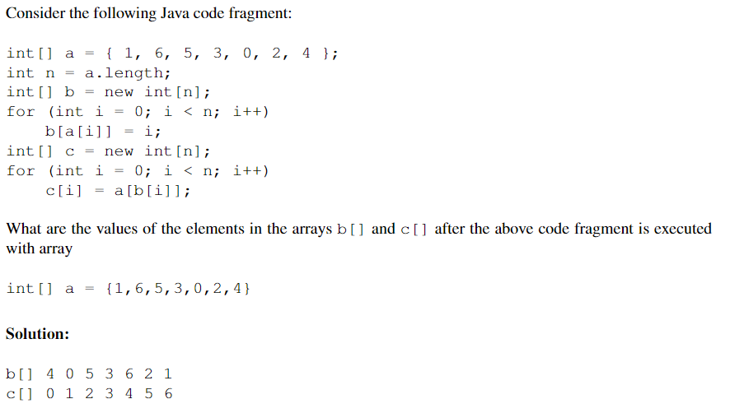

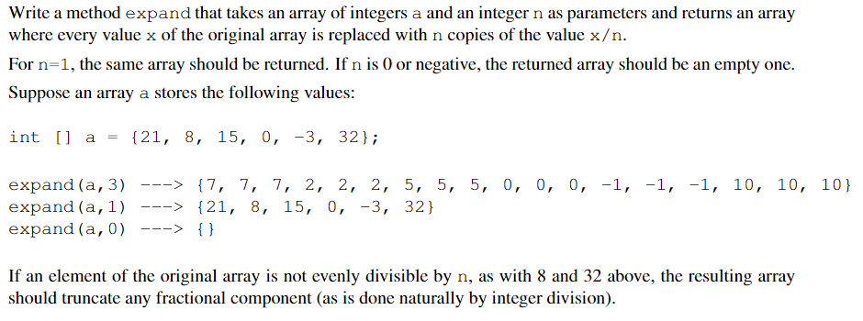**Problem -1 (Expand List)**

**Practical**

**Problem -2 (Reverse List ( reverse in place))**

**Write a java function that reverses the order of elements of the given list.**

**Problem -1(**Print Repeated**)**

**Assignment**

Write a function that given an ordered list of integers A prints the elements in the list that are repeated. If some elements occur more than twice, then these elements should be printed only once.

For example, the list

1 1 1 1 4 6 7 7 8

your algorithm should print : 1 7

**Problem -2**

write a java function that given a hexadecimal number and return it’s equivalent octal number, design a function that convert from hex to binary, then from binary to decimal to use in

public static String Hex_Oct(String s)

public static String Dec_Bin(char c)

public static String Bin_Dec (String s)

Hint: call Dec_Bin and Bin_Dec inside Hex_Oct

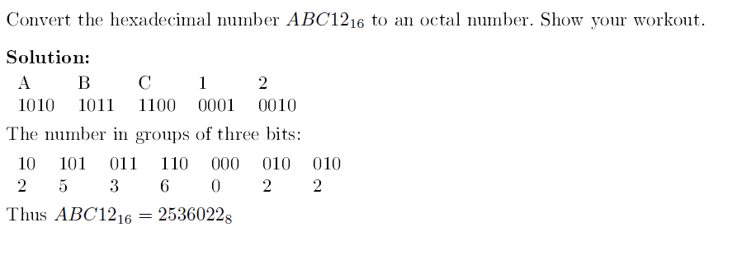

**Problem -3**

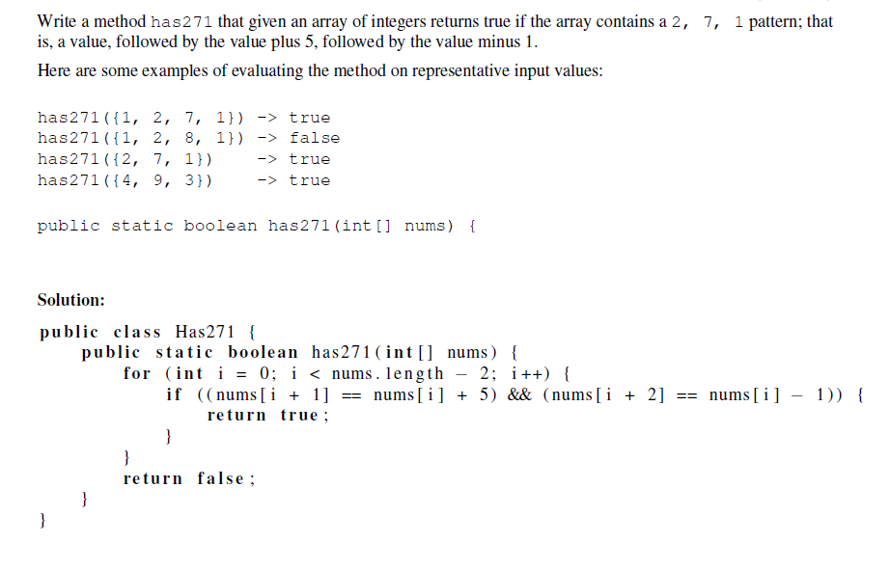

**Problem -4(**Check Sorted List**)**

**a list A of numbers, write an algorithm to check whether the list is sorted in ascending order or not.**

**public static boolean Ordered(int []list)**

**{**

**int counter=0;**

**for (int i = 0; i < list.length-1; i++) {**

**if(list[i]<=list[i+1])**

**{**

**counter++;**

**}**

**}**

**if(counter==list.length-1)**

**{**

**return true;**

**}**

**else**

**{**

**return false;**

**}**

**}**

**public static void main(String[] args) {**

**int [] Input;**

**int n;**

**Scanner sc = new Scanner (System.*in*);**

**System.*out*.println("Please enter array size");**

**n= sc.nextInt();**

**Input =new int[n];**

**for (int i = 0; i < Input.length; i++) {**

**Input[i] =sc.nextInt();**

**}**

**if(*Ordered*(Input))**

**System.*out*.println("Sorted");**

**else**

**System.*out*.println("UnSorted");**

**}**